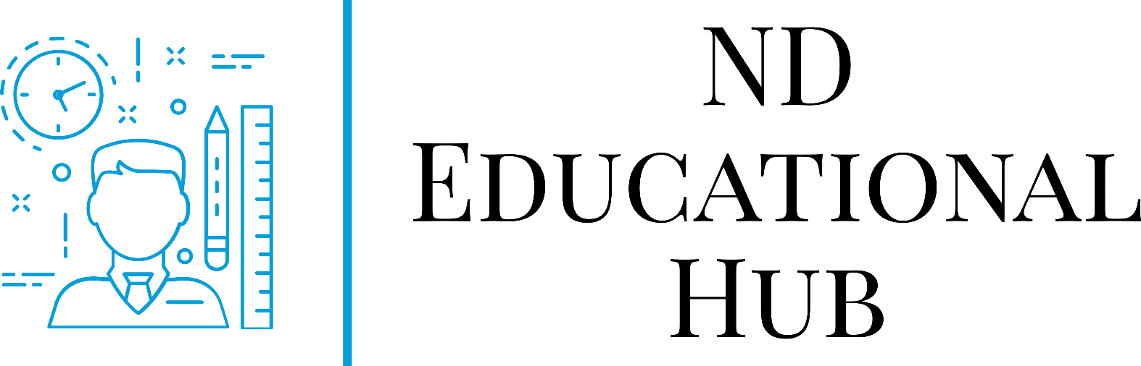

NORTH DAKOTA EDUCATIONAL HUB
“EMPOWERING NORTH DAKOTA EDUCATOR ACCESS TO PROFESSIONAL LEARNING”

Website: https://my.ndeducationalhub.org/login/index.php

User Guide Manual

Table of Contents
Content………………………………………………….……………….….…….3
Course Guidance.……………………………….……………………….…….3-4
Important Considerations………………………………..................................................4
Frequently Asked Questions ………………………….……………………..…5
Quick Start Guide…………………………………………………………...….6-7

ND Educational Hub Admin Team Contact Information:

Kevin Leier- Director/Lead Technical Assistance

Brooklyn Schaan- Assistant Director/Policy and Marketing

Leah Johnson- Assistant Director/Content Development
NDEDHUB@K12.ND.US

Course Content
Content is added and made available on a Trimester basis. There are two ways to view the most recent content.

Course Content Development Timeline
Timeline (link inserted)

Course Content Catalog
Document showing current content live or under development (link inserted)
To request specific content, contact a REA Tenant Manager or ND Hub Admin Team.
Persons interested in creating content should contact their local REA’s ND Educational Hub tenant manager or the Hub Admin Team.

Course Guidance

Course Enrollment
To enroll in a course, persons must first create a free account on the ND Educational Hub website. For information on how to create an account, please see the Quick Start Guide on page 6 of this manual.
Enrollment Steps:
- Look for “All Available Courses” on the Dashboard.
- Choose from “Statewide PD and Trainings”, “Individualized PD Courses”, or local REA tenant.
- Free available classes will say “Enroll”.
- Classes available for a small fee will say “Add to Cart”.
- Once enrolled, the class will be available under “My Courses”.
  - Note: Some courses will require enrollment by the instructor. If that is applicable, users will be notified ahead of time.

Course Unenrollment
Users will be automatically unenrolled from a self-paced course after 60 days of inactivity. Users will be removed from a facilitated course 60 days after completion of course.
If users are signed up for a course that they can no longer attend and wish to unenroll before 60 days, contact the course instructor.

Completion Certificates
Users should save all course completion certificates to their computer directly upon completion of the course for personal records. It is also suggested that users print a hard copy to store in a safe place for easy reference when needed. Course certificates for completed courses can be found under the user profile. The Hub Admin Team and Tenant Managers are not responsible for retrieving user certificates.

Credit Registration
Some courses are available for credit. Each course will specify the necessary information including university, instructor, and cost. The user is responsible for registering for the credit by the deadline. It is not up to the course facilitators, nor do they have any role in being able to register a user after the deadline. The Hub is not responsible for returning user’s credit registration fee if course is not completed or credit registration deadline is missed. Please check with the ND teacher licensing board if unsure if the credit will be accepted for credit renewal.

Important Considerations

Forgot Password or Username
If users forget passwords or usernames, they can click on the bottom on the website to reset or retrieve.

YouTube
Many courses include YouTube videos. If a user’s internet filters block YouTube, they may struggle to complete certain courses. It is recommended users test video functionality or pop-up blockers in advance.

Course Completions
It is the responsibility of the user to complete the course to its entirety for a course completion certificate. If a user completed a course but the course completion certificate is not working, please contact the course instructor first to ensure everything was completed as assigned. If additional help is needed after contacting the course instructor, please contact the Hub Admin Team.

Frequently Asked Questions (FAQ)

Do Educational Hub courses count towards renewing my ND Educator License?
Some courses are available for credit that can count toward license renewal. Other courses are only based on hours of completion. Please read each course description and syllabus carefully for details on obtaining credit.

Do I receive a grade?
Each course is different, but the following description applies to most. Self-paced courses are based on completion, but participants may receive scores for individual activities. Facilitated courses are pass/fail unless otherwise noted. For more details about the grading for a specific facilitated course, please contact the listed facilitator of the course.

What happens with the feedback I give on the course evaluation?
Each month the instructor or facilitator reviews the data from evaluations. The Hub Admin Team reviews that data each trimester. The Hub strives to only offer high-quality courses and use evaluations to help meet that goal.

How do I know how long each course will take?
The length of each course can vary and will be specified in the course description or syllabus. Generally, a credit-bearing course requires approximately 15 hours to complete.

I can’t remember my password.
First, try the Forgot My Password button on the login page. If assistance is still needed, contact the Hub Admin Team.

How do I update my email or registration information?
Go to your profile picture in the upper right-hand corner of your Hub homepage. Click on the drop-down arrow to the right. Click “Profile” and then “Edit Profile”. Change desired items then click “Save”.

Can I view courses on my phone or tablet?
Yes, the Hub can be accessed either through a browser on a phone/tablet or through the free OpenLMS Mobile App. The app is available from Google Play and the Apple Store. If using a browser on a phone or Safari on a tablet, please know that some activities may not function properly. The system works best with Firefox or Chrome on a computer.

How often are courses added?
Courses are added in the Fall, Spring, and Summer trimesters for statewide access. Creating new courses and refreshing existing ones are on-going. Tenant or school district-specific courses (Tier 3) are added as needed.

I completed a course, where is my course completion certificate?
To view or print a course completion certificate click on your profile picture in the top right corner of the dashboard. Choose profile from the drop-down menu. Click on My Certificates under Miscellaneous.

Quick Start Guide
- Go to https://my.ndeducationalhub.org/login/index.php . Click on Create New Account and proceed to register for your account.

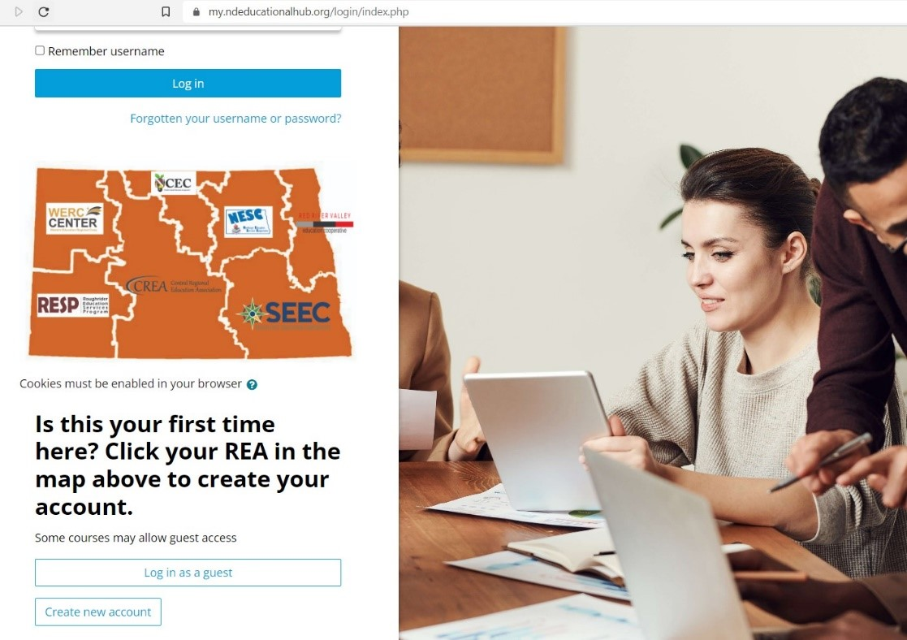

- Once logged in, you will land on the dashboard for your new ND Educational Hub Account. Click on “All Available Courses” to see what potential courses are available for you.
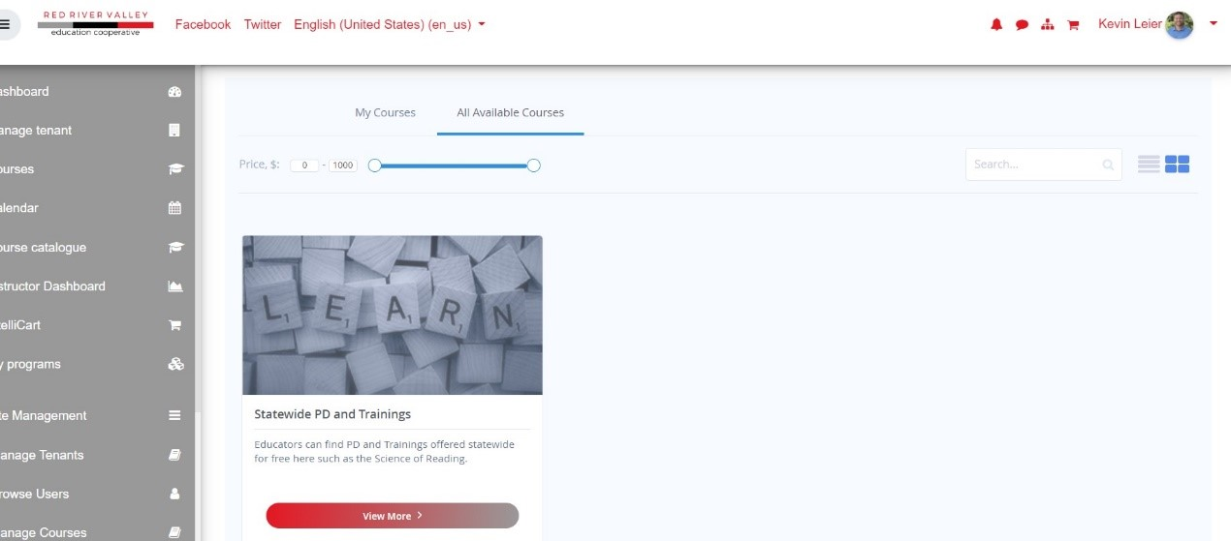
- Once enrolled in a course, it will automatically show up on your dashboard once logged in under “My Courses”. 